|  |  |  |  |
| --- | --- | --- | --- |
| **monlau-pequeño** | | **M3 - Programació** | |
| **UF1** | **10/10/19** |
| ***Rosa Rey, Edgar*** | | | |
| **Práctica Nº: 04** | **If & else** | | |

1)-(Apto/No Apto): Pedir la nota del user y decir si está aprobado o no.

|  |
| --- |
| /*  07/10/19  */  //Author: Edgar  package m3uf1p04;  //Libraries:  import java.util.Scanner;  public class M3uf1p04 {  // Global Declarations:  static Scanner keyboard=new Scanner(System.in);  public static void main(String[] args) {  P1();  }  public static void P1(){  System.out.println("Mark ?:");  float mark=keyboard.nextFloat();  if(mark>=5){  System.out.println("Approved");  }  else{  System.out.println("Not approved");    }  }  } |

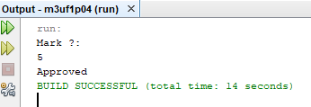

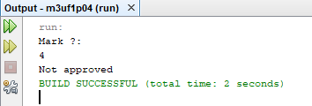

2)-(carnet de conducir): Pedir la edad del usery decir si puede sacar el carnet de conducir o no.

|  |
| --- |
| /*  10/10/19  */  //Author: Edgar  package m3uf1p04;  //Libraries:  import java.util.Scanner;  public class M3uf1p04 {  // Global Declarations:  static Scanner keyboard=new Scanner(System.in);  public static void main(String[] args) {  P2();  }  public static void P2(){  System.out.println("How old are you?:");  int mark=keyboard.nextInt();  if(mark>=18){  System.out.println("You can drive");  }  else{  System.out.println("You can't drive");    }  }  } |

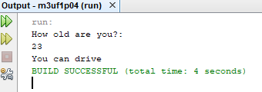

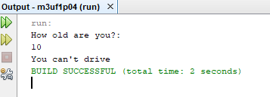

3)- (mayor): Pedir 2 números y decir si son iguales.

|  |
| --- |
| /*  10/10/19  */  //Author: Edgar  package m3uf1p04;  //Libraries:  import java.util.Scanner;  public class M3uf1p04 {  // Global Declarations:  static Scanner keyboard=new Scanner(System.in);  public static void main(String[] args) {  P3();  }  public static void P3(){  System.out.print("Number1 ?:");  float num1=keyboard.nextFloat();  System.out.print("Number2 ?:");  float num2=keyboard.nextFloat();  if(num1==num2){  System.out.println("equal numbers");  }  else{  System.out.println("they are not equal");    }  }  } |

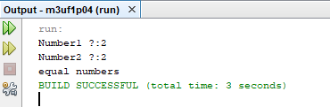

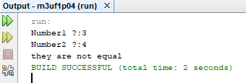

4)- (mayor): Pedir 2 números y decir cuál es mayor.

|  |
| --- |
| /*  10/10/19  */  //Author: Edgar  package m3uf1p04;  //Libraries:  import java.util.Scanner;  public class M3uf1p04 {  // Global Declarations:  static Scanner keyboard=new Scanner(System.in);  public static void main(String[] args) {  P4();  }  public static void P4(){  System.out.print("Number1 ?:");  float num1=keyboard.nextFloat();  System.out.print("Number2 ?:");  float num2=keyboard.nextFloat();  if(num1<num2){  System.out.println("number 1 is more bigger than number 2");  }  else{  System.out.println("number 2 is more bigger than number 1");    }  }  } |

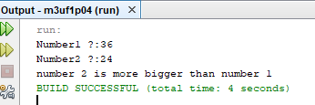

5)- (menor): Pedir 2 números y decir cuál es menor.

|  |
| --- |
| /*  10/10/19  */  //Author: Edgar  package m3uf1p04;  //Libraries:  import java.util.Scanner;  public class M3uf1p04 {  // Global Declarations:  static Scanner keyboard=new Scanner(System.in);  public static void main(String[] args) {  P5();  }  public static void P5(){  System.out.print("Number1 ?:");  float num1=keyboard.nextFloat();  System.out.print("Number2 ?:");  float num2=keyboard.nextFloat();  if(num1<num2){  System.out.println("number 1 is more smaller than number 2");  }  else{  System.out.println("number 2 is more smaller than number 1");    }  }  } |

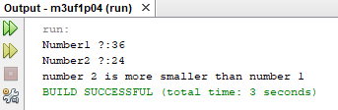

6)- (ganador): En un partido de futbol entre 2 equipos (Local y Visitante), pedir el número de goles marcados por cada equipo y decir qué equipo ha ganado o si han empatado.

|  |
| --- |
| /*  10/10/19  */  //Author: Edgar  package m3uf1p04;  //Libraries:  import java.util.Scanner;  public class M3uf1p04 {  // Global Declarations:  static Scanner keyboard=new Scanner(System.in);  public static void main(String[] args) {  P6();  }  public static void P6(){  System.out.println("How many goals has the visiting team scored?");  int num1=keyboard.nextInt();  System.out.println("How many goals has the local team scored?");  int num2=keyboard.nextInt();  if(num1>num2){  System.out.println("the visiting team has won");  }  if(num1<num2){  System.out.println("the local team has won");    }  if(num1==num2)  {  System.out.println("draw");    }    }  } |

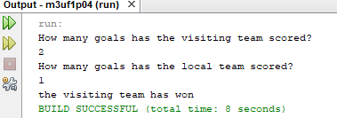

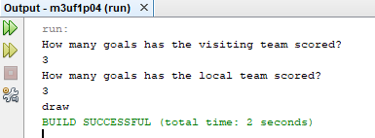

7)- (triángulo): Pedir los 3 lados de un triángulo y decir si es equilátero (los 3 lados iguales)

|  |
| --- |
| /*  10/10/19  */  //Author: Edgar  package m3uf1p04;  //Libraries:  import java.util.Scanner;  public class M3uf1p04 {  // Global Declarations:  static Scanner keyboard=new Scanner(System.in);  public static void main(String[] args) {  P7();  }  public static void P7(){  float num1, num2, num3;    System.out.println("how long is side 1");  num1= keyboard.nextFloat();    System.out.println("how long is side 2?");  num2= keyboard.nextFloat();    System.out.println("how long is side 3?");  num3= keyboard.nextFloat();    if(num1==num2&&num1==num3&&num2==num3)  {  System.out.println("equilateral triangle");  }  else  {  System.out.println("it is not an equilateral triangle");    }    }  } |

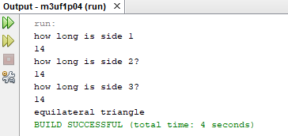

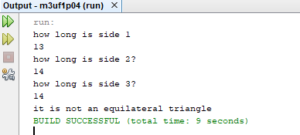

8)- (par/impar): Pedir un número y decir si es par o impar.

|  |
| --- |
| /*  10/10/19  */  //Author: Edgar  package m3uf1p04;  //Libraries:  import java.util.Scanner;  public class M3uf1p04 {  // Global Declarations:  static Scanner keyboard=new Scanner(System.in);  public static void main(String[] args) {  P8();  }  public static void P8(){  int num1,num2;    System.out.println("Number1 ?");  num1= keyboard.nextInt();  num2=num1%2;    if(num2==0)  {  System.out.println("even number");  }  else  {  System.out.println("odd number");    }    }  } |

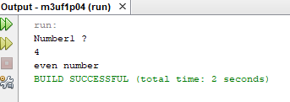

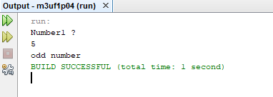

9)- (divisible entre 7): Pedir un número y decir si divisible entre 7 o no

|  |
| --- |
| /*  10/10/19  */  //Author: Edgar  package m3uf1p04;  //Libraries:  import java.util.Scanner;  public class M3uf1p04 {  // Global Declarations:  static Scanner keyboard=new Scanner(System.in);  public static void main(String[] args) {  P9();  }  public static void P9(){  int num1,num2;    System.out.println("Number1 ?");  num1= keyboard.nextInt();  num2=num1%7;    if(num2==0)  {  System.out.println("it is divisible of 7");  }  else  {  System.out.println("it is not divisible of 7");    }    }  } |

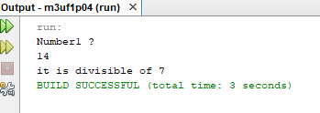

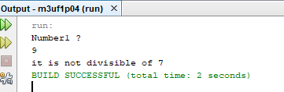

10)-( if-else)- explica la estructura if-else

The if-else structure is based on a true or false or we could also say if it meets the condition or not. If it meets the condition we have put in parentheses, it is an if, if it does not meet it, it is an else.